ARP 2024-5
Ethical Action Plan

Name of practitioner-researcher: Michael Ste. Croix m.stecroix0920231@arts.ac.uk
06/10/2024

- What is your project focus?

How do I help students with ‘unseen’ disabilities-like autism, deafness, anxiety, mental health- so that they have greater engagement with the course they are studying and be fully involved with the college/university education community.

‘Inclusivity for all’ being the watch word I am keen to support and adhere to, as there are students who will not reveal their disabilities publicly which can cause ‘barriers to inclusion’. We, teachers must adjust and be critical in how we deliver our lessons that are accessible for all. The subtleties of non-verbal communications and the difficulties it can pose for some individuals is also very important for us to be aware of.

With reference to my ‘Micro-Teaching Part 2 ‘Reflection on my teaching and presentation of subject’. I would like to develop a physical tool in which the students can explore through touch and manipulation to reveal the ‘unseen’ disabilities they are facing and to encourage discussion within the student body; hopefully allowing those students the confidence to reveal their unseen disability and get the teaching support they need to complete their course with confidence.

Can the intervention generate multiple versions of the cube i.e. can my cube be replicated repeatedly and again and again?

- What are you going to read about?

Most of my reading material will be led by my research an investigation into ‘disabilities’ and how it can be supported within an educational environment/community.

Apart from the reading material provided by this unit PgCert ‘Action Research Project’ as a springboard to launch my study. I will be revisiting past reading material that I have used as part of my journey (my teaching development and evolution and at times ‘enlightenment’) on this course; titles listed below, as well as adjacent materials that has stimulated further influence on my thoughts on education and teaching; some of the subjects may not have obvious links but the content within will have had impact in the way I am approaching this project.

Please find below links, book titles, Podcast sites, video links and names of practitioners:

Cleary V (05 July 2024) Thinking through making: What kinds of learning take place when HE students engage with creative arts technicians

https://doi.org/10.1386/adch-00087_1
Verity Cleary has asserted their right under the Copyright, Designs and Patents Act, 1988, to be identified as the author of this work in the format that was submitted to Intellect Ltd.
https://www.mencap.org.uk/learning-disability-explained/conditions-linked-learning-disability/autism-and-aspergers-syndrome – :~:text=Autism%20is%20not%20a%20learning,also%20have%20a%20learning%20disability.

Search for: Is autism a learning disability in NHS?
Posted in Uncategorised | 6 Comments | Edit
Kimberle Crenshaw: What is Intersectionality?
https://www.youtube.com/watch?v=ViDtnfQ9FHc
946,575 views 22 Jun 2018
https://www.mencap.org.uk/learning-disability-explained/conditions-linked-learning-disability/autism-and-aspergers-syndrome – :~:text=Autism%20is%20not%20a%20learning,also%20have%20a%20learning%20disability.

Search for: Is autism a learning disability in NHS?
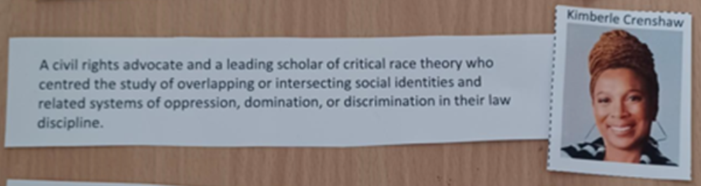
Crenshaw, K (1991) Mapping the Margins: Intersectionality, Identity Politics and Violence against Women of Color, Source: Stanford Law Review, , Jul, 1991, Vol. 43, No. 6 (Jul.1991). pp.1241-1299
Aziz, R (1997) Feminism and the challenge of racism: Deviance or difference? In Black British Feminism, ed. Mirza, H. S. London, Routledge, pp. 70-77.
Choudrey, S. (2016) Inclusivity-Supporting BAME Trans People [Online]. Gender Identity Research & Education Society, 14 February. Available from:
Orr, S, & Shreeve, A 2017, Art and Design Pedagogy in Higher Education: Knowledge, Values and Ambiguity in the Creative Curriculum, Taylor & Francis Group, Milton. Available from: ProQuest Ebook Central. [1 January 2024] Created from ual on 2024-01-14:50:26
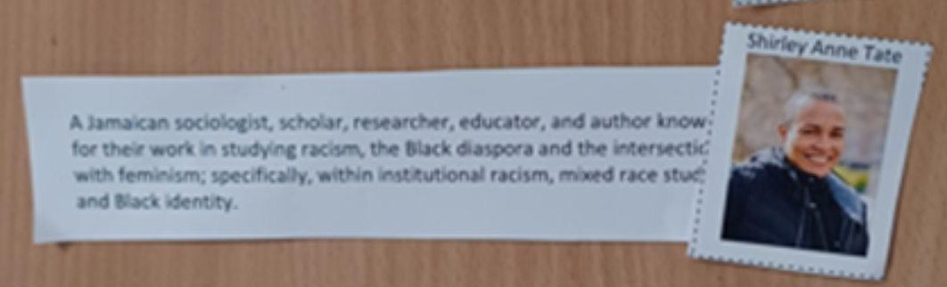
Willcocks, J & Mahon, K (2023) ‘in commerce the potential of online object-based learning activities to support the teaching of intersectional environmentalism in art and design in high education ’.’Art, Design & Communication in Higher Education’, (Volume 22) p. 187-207
Sam, C (2016) ‘How do art design technicians conceive of their role in higher education’ Spark: UAL Creative Teaching and Learning Journal Vol 1 / Issue 2 (2016) pp. 62-69
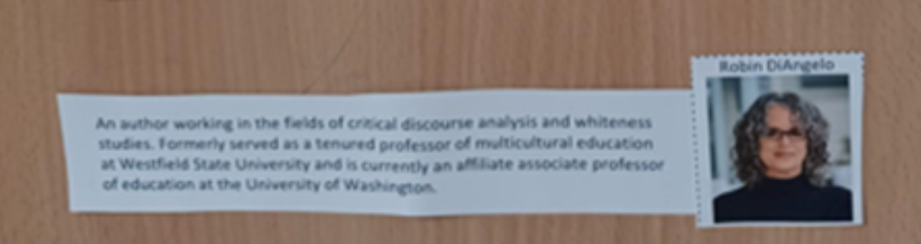
Willcocks, J & Mahon, K,-‘The potential of online object-based learning activities to support the teaching of intersectional environmentalism in art and design higher education’
Brown, C (2023) ‘Intersectionality in Focus: Empowering Voices during OK Disability History Month 2023’ (2023) web: https://www.youtube.com/watch?v=_yID8_s5tjc
Choudrey, S. (2016) Inclusivity-Supporting BAME Trans People [Online]. Gender Identity Research & Education Society, 14 February. Available from:
Citation: Thomas, Cate. 2022. Overcoming Identity Threat: Using Persona Pedagogy in Intersectionality and Inclusion Training. Social Sciences 11: 249. https://doi.org/10.3390/ socsci11060249 Academic Editor: Nigel Parton Received: 25 March 2022 Accepted: 30 May 2022 Published: 2 June 2022
(Disability and Race Ade Adepitan (-2021) web: https://www.youtube.com/watch?v=KAsxndpgagU
Christine Sun Kim in “Friends & Strangers” (2023) web: https://www.youtube.com/watch?v=2NpRaEDlLsI
Chay Brown Intersectionality in Focus: Empowering Voices during OK Disability History Month 2023 (2023) web: https://www.youtube.com/watch?v=_yID8_s5tjc
Walmsley J (2001) Normalisation, Emancipatory Research and Inclusive Research in Learning Disability, Disability & Society, 16:2, 187-205, DOI: 10.1080/09687590120035807 To link to this article: https://doi.org/10.1080/09687590120035807
Brown M. K (2004) Leadership for Social Justice and Equity: Weaving a Transformative Framework and Pedagogy Educational Administration Quarterly Vol. 40, No. 1 (February 2004) 77-108
Books:

The Black Experience in Design-Identity Expression & Reflection
Black Futures- Kimberly Drew & Jenna Wortham
I Am Not Your Negro-James Baldwin Penguin Modern Classics)
Misogynoir, Black Women’s Digital Resistance-Moya Bailey
James Obrian-How They Broke Britain
Cool Infographics-Randy Krum
Knowledge is Beautiful-David McCandless
Introducing Slavoj Zizek-A Graphic Guide

Podcast:

Philosophize This!

Practitioners:

Peter Gregory Boghossian is an American philosopher and college professor-his name was mentioned during PgCert workshop 1

Michael Foucault French philosopher-his name was mentioned during PgCert workshop 1

Carys Kennedy Educational Developer (Reward and Recognition)
Academic Practice-advised to contact her on her knowledge of Disability Professional, educator, coach, sociolinguist. UAL.

Website:

Will refer to CASE website for reference and further reading which will feed in towards my research-inclusive practice -CASE-scaffold the ideas around disability, inclusive practice unit. CASE Training | Learning Disability Services | Hull (casetraininghull.co.uk)

- What action are you going to take in your teaching practice?

Disabilities is a difficult issue, for us as teachers to engage with and complicated at times when supporting a student need if the disability is hidden and you are not made aware of it, like deafness, anxiety, autism. It requires creative approaches to address these problems

I will create a safe teaching space. An appropriate teaching space will be found or created for the class research to take place.

I will construct a physical cube that the students can use if they are not prepared to speak out openly amongst fellow students-to document the disability without revealing their identity. The cube will allow them to write on surfaces and name visible and ‘unseen’ disabilities.

To encourage classroom discussion and explore themes on disabilities. Attached is image of first construction draft of cube which can trans configure into a different configuration revealing the intersections of the visible and unseen disabilities, with the opportunity to discuss and explore solutions. I will make observational notes and record data if it is useful. All the time making sure I have the student’s consent.

Engage with small student groups to discuss and exploring if the cube can be used in another way.
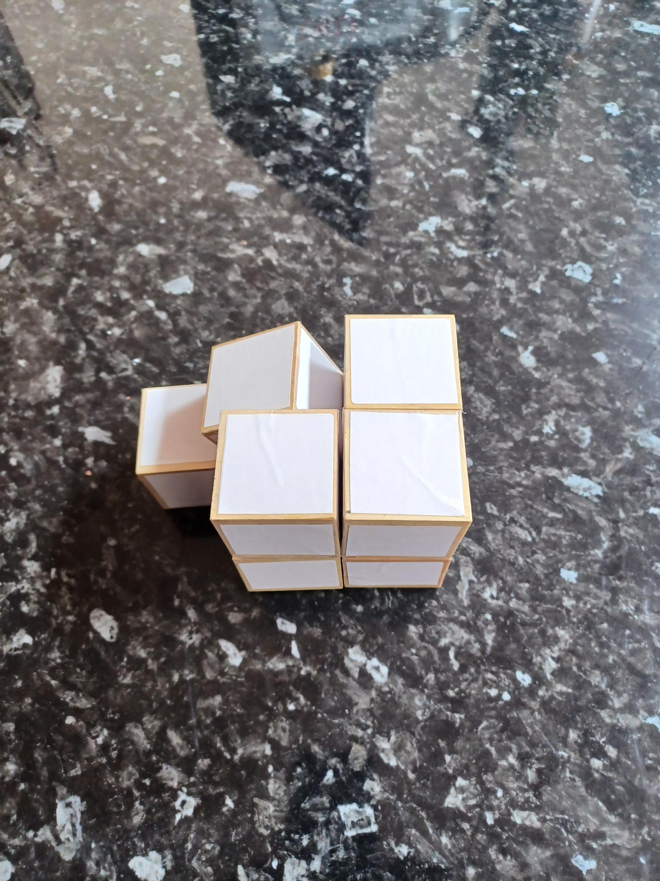
Image attached is first draft of cube construction

Students may not be willing to share their personal information. I must respect their decision and ensure their wishes are enforced.

Must be aware that this will be personal information being shared and must have systems in place where stress and emotional relapse may occur and that there is support UAL student support services are in place and available.

Can the intervention generate multiple artifacts i.e. can my cube be replicated repeatedly and again and again?

My action

Create a safe environment for student to reveal their disabilities.

Create a list of questions to encourage open debate on disabilities, intersectionality, and inclusivity.

Record and observe how students use the teaching material.

Did the student understand the aims of the class and learning outcomes?

Do further research in how UAL supports students with disabilities, especially those students who suffer from anxiety and study work related stress.

Some Questions to be used during research on disabilities:
- What do you think the term “disability” means?
- Can you name some different types of disabilities?
- How do you think disabilities can affect a person’s daily life?
- What are some common misconceptions about people with disabilities?
- How can society be more inclusive and supportive of people with disabilities?
- Have you ever met or known someone with a disability? What did you learn from them?
- What are some ways technology can help people with disabilities?
- Why is it important to use respectful language when talking about disabilities?
- How can schools and workplaces be made more accessible for people with disabilities?
- What can you do to support and advocate for people with disabilities in your community?
- These questions can help foster a deeper understanding and empathy towards people with disabilities.
Some Questions to be used during research on unseen disabilities:
- What do you think the term “unseen disability” means?
- Can you name some examples of unseen disabilities?
- How might unseen disabilities affect a person’s daily life differently than visible disabilities?
- Why do you think unseen disabilities might be harder for others to understand or recognize?
- What are some challenges people with unseen disabilities might face in school or work environments?
- How can we support classmates or colleagues who have unseen disabilities?
- Why is it important to believe and respect someone when they say they have an unseen disability?
- How can we raise awareness about unseen disabilities in our community?
- What role does empathy play in understanding and supporting people with unseen disabilities?
- How can technology or accommodations help people with unseen disabilities?
- These questions can help students develop a deeper understanding and empathy towards those with unseen disabilities

- Who will be involved and how?

Create a safe space for students to openly, of their own volition to talk freely on themes of ‘unseen’ disabilities and what it means to them.

Engage with small students’ groups to discuss and exploring if the cube can be used to support discussion on disabilities.

Engage with small students’ groups to discuss and exploring if the cube can be used in another way.

I will involve students, technicians and present academic staff within my programme to give feedback and use as a source of data in how it can be used in support of teaching.

If time permitting, explore different types of construction materials that can be used in the making of the cube and for it to cater for all user: consider colour, physical material; consider physical and sight disabilities.

NO STUDENTS UNDER THE AGE OF 18 WILL BE INVOLVED

N.B. If any of your participants/co-researchers will be under 18, please seek advice from your tutor.

- What are the health & safety concerns, and how will you prepare for them?

Students may not be willing to share their personal information. I must respect their decision.

Must be aware that this will be personal information being shared and must have systems in place where stress and emotional relapse may occur and support to be place and help available.

Create a questionnaire to let students/participants know how the data
/Research will be used and to give researcher warning if there are elements in the questions that they are not happy with.

Alert students/participants of possible trigger warnings.

Write a Risk Assessment Method statement for students’ engagement with project.
How does this impact on students and UAL policies.

Create safe space for class to take place.

Will make sure that the student identity will not be recognisable and will delete any traces that links to that student.

Create a safe working environment for student and researcher. Be aware of student and researchers’ health and safety needs. Ensure the teaching/learning environment is appropriate for the ‘research class to take place.

- How will you protect the data of those involved?

Data will not be shared but only used to complete this part of my PgCert course.

No names, class, sex, gender or any other personal details/data will be recorded. A code system will be used-i.e. create a numerical, alphabetical code to recognise data input for reference for final assessment and presentation/evidence for final course assessment and marking.

Students will sign a document that will protect them and the researcher that the data will only be used to complete this part of my PgCert course. Data will not be shared.

- How will you work with your participants in an ethical way?

Students write a consent form.

Create a Risk Assessment Method Statement.

Supply student with Information sheet, what are the aims of my research.

Tell them in-depth in what I am trying to achieve and why I am doing it.

Choose a selected body of students/invite students to be part of the cube research-session (advertise through online invite or from college student body)

Will meet students in classroom, present research project to students and then carryout certain project exercises and practical work in discovering unseen disabilities.
Where appropriate, teaching material will be used to support research project.

The students can withdraw from the research project at any time- during the class or any future engagement with the project.

ATTENTION: REVISED ETHICAL ACTION PLAN OUTCOMES DUE TO THE SENSITIVITY OF RESEARCH AIMS AND SUBJECT MATERIAL DISCUSSED. WITH REFERENCE TO HIGHLIGHTED OBJECTIVE HEADINGS BELOW:

3. What action are you going to take in your teaching practice

To encourage classroom discussion and explore themes on disabilities. Attached is image of first construction draft of cube which can trans configure into a different configuration revealing the intersections of the visible and unseen disabilities, with the opportunity to discuss and explore solutions. I will make observational notes and record data if it is useful. All the time making sure I have the student’s consent.

Due to the personal sensitivity of ‘unseen disabilities and the information that maybe revealed and shared through a safe workshop environment for students; has led me to re-evaluate this aspect of my research. There is a strong possibility that I might trigger painful, private, personal trauma within a student that I am not be able to support or give immediate comfort/aid if student/s has a mental break down or I cause harm. I am not trained or qualified to handle this type of situation with a student/s. I will not advertise for students to take part in my research on the grounds of safety for the researcher and the student.

I will therefore present all the research material and data leading up to the stage where I would have engaged students’ participation and the reasons why. This will end one part of the research cycle.

But this has opened another cycle of research in how society impacts on the disabled. Through 1:1 tutorial with my tutors and practitioners and using my Action Research Plan on ‘unseen disability’ as a foundation of resource material, I want to look at the ‘Social Model’ of disability that is created by society and the barriers (the seen and unseen) that stops them from being part of society that non-disable people do not face.

4. Who will be involved and how?

I will involve students, technicians and present academic staff within my programme to
give feedback and use as a source of data in how it can be used in support of teaching

I will continue my research and gather data from the critical feedback from technicians, academics and practitioners, who I have contacted, and been given the cube to
review and assess its use with the option to explore other possibilities as a teaching tool.

